# Introduction

VenAqua Visualization Report application is a middleware application which interacts with CORE DB 2.0 in the existing VenAqua architecture. VenAqua Visualization Report fetches required data from CORE DB system and manipulates it as needed to visualize in the front end application. It publishes these information as SOAP based Web Service API. Internal components or a third party application can communicate to VenAqua Visualization Report application via its published Web Services API.

VenAqua Visualization Report application collects and manipulates data from the CORE DB system, such as

* Water Consumption from different sources in a site
* Water Consumption for individual house
* Various water types and their demand in a site
* Pump’s ON/OFF states and their yields
* Various water sources and its performance

# Communication Architecture

The below diagram shows how the Visualization Report application can be invoked from the front end application.

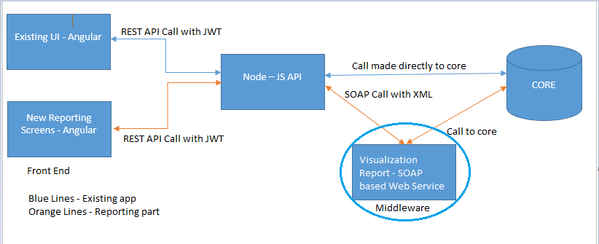

In this architecture, the third party applications must be authenticated by the middleware application in order to communicate further. In the subsequent calls, the third party application must send their access token which is received in the previous call.

# Visualization Report Architecture

Visualization Report application has divided into multiple sub modules, each modules have their own roles to prepare desired data to the front end or third party application.

**General Utility**

**SOAP  
Web Services**

**CORE ENGINE**

**DB  
Handler**

**Web Services**

**CORE DB  
2.0**

**Token   
Manager**

**Authentication  
Handler**

**Data Preparer**

**Error Handler**

## General Utility

General utility module contains classes which are related to utility purpose. These classes are used across all the modules in this architecture.

## SOAP Web Services

## Core Engine

## Authentication Handler

## Token Manager

## DB Handler

## Data Preparer

## Error Handler